**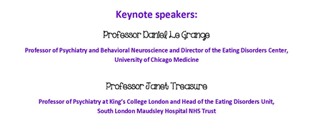**

A ‘First’ for Australia

A conference for families and carers of those with eating disorders!

Best evidence treatment for eating disorders reveals that the close involvement of families and carers in the care of their loved ones is invaluable in improving early detection, restoration to a healthy weight and maintaining long term wellbeing. For parents and carers, however, the journey can be confusing, challenging and difficult to navigate.

The primary aim of this inaugural Conference is to provide access to a range of expert knowledge and skills for families and caregivers of people with eating disorders, so that they can go home feeling empowered, better informed and more able to support, care for and assist in the recovery of the person with the eating disorder. To do this the conference will:

* Provide presentations from leading health professionals sharing the latest evidence on what works for treating ED’s.
* Provide opportunities for families and carers to share information on what worked (and what didn’t work) for them.
* Provide practical forums to help carers support their relative, friend or loved one with an eating disorder.

The Conference will also provide families and carers of people with eating disorders with opportunities to network and connect with other people with similar experience, in a safe and supported environment, so that they can benefit and gain confidence and new insights from shared knowledge and experience. To do this the conference will:

* Provide opportunities within the program for networking and sharing of experiences.
* Identify and make provision to meet pastoral care needs of those attending if required.
* Provide opportunities for social activities.

We also welcome clinicians, therapists and sufferers wanting to learn more about and be inspired by the role of families and carers in supporting recovery.   
 For more info go to: <http://www.athomewitheatingdisorders.com>

Or email [admin@athomewitheatingdisorders.com](mailto:admin@athomewitheatingdisorders.com" \t "_blank)