Sufferers – an untapped resource in the field of eating disorders

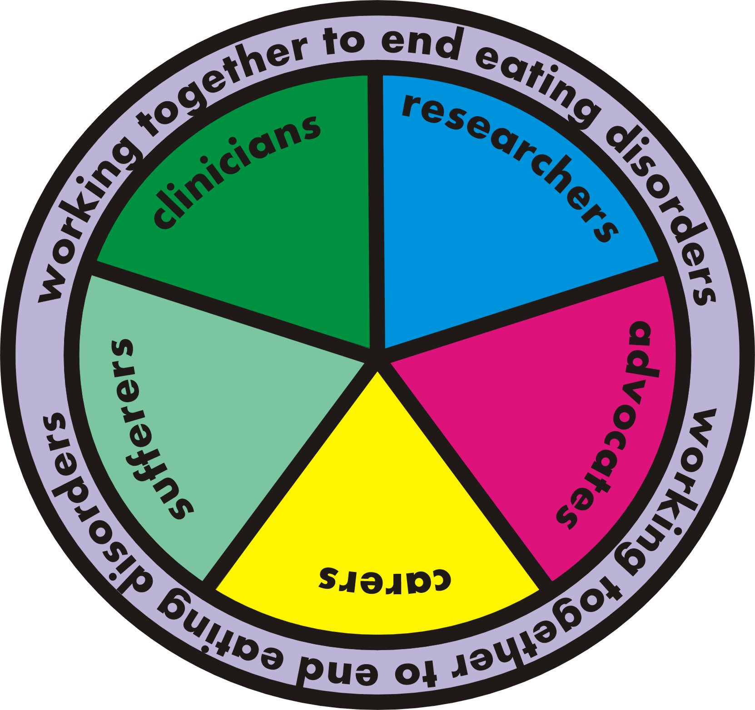

By June Alexander
I come from the 'sufferer' or 'person with the eating disorder' background, and over recent years I have started to wonder why more people 'like me' are not at eating disorder conferences – which I always find helpful and nurturing.
I reached out to others in the ED field, and discussion has led to the current article. We all - researchers, treatment providers, advocates, carers and ... yes, SUFFERERS - must be acknowledged as part of the solution in the quest to understand, treat and prevent eating disorders. When a problem needs solving, it helps to have contributions from diverse problem-solvers whose experiences and approaches differ. Each person and institution in whatever capacity has a crucial and different role to play in eradicating "Ed”. A solution cannot be discovered in a vacuum. This paper is a call for sufferers of eating disorders to be given more opportunity to contribute. At the very least, we all will learn by keeping this topic open for discussion. We owe this much to one another – expert, clinician, carer and sufferer alike.

I am a partner, mother, grandmother - and a former sufferer of Anorexia and Bulimia, and the co-morbid issues of anxiety and depression. Like many sufferers - who missed out on treatment as a child but have been sufficiently high functioning to proceed to adulthood, often taking on roles of partner and parenthood, and holding down a challenging professional job as well - I suffered silently for many years. I would have loved to attend an eating disorder conference in my 20s or 30s – it would have helped immensely. Ideally I would have attended with my partner, but if I attended alone I would have learnt that my feelings of constant torment and inadequacy were due to an illness, that I was not alone, and that I could recover more quickly if my husband became part of my treatment team. This would have been an enormous step forward.

Let’s do away with shame
People talk about ‘coming out’ in terms of gays and lesbians. I can relate to this. I ‘came out’ as a ‘person with an eating disorder’ at age 55, the year I regained me, in 2006. For 44 years, I had been a ‘closet’ eating disorder sufferer. My eating disorder had been a shameful, guilt-laden, soul-destroying secret. But in the darkest moments of my illness I had clung to an unshakeable belief and image that recovery required getting illness into the open. An eating disorder is manipulative and devious; it thrives in the dark; it likes to hide. Shining a bright light, raising awareness – this was the way to exterminate it. Such thoughts sustained me at my sickest points. Upon recovery, I became dedicated to providing hope for others. I didn’t want others to suffer, or be misunderstood, like me. My pen, which had been a survival tool, became a sword. I transitioned from newspaper journalist to writing books about eating disorders. I began attending conferences on eating disorders and amazing things began to happen.

Let’s be At Home with Eating Disorders
One of the biggest revelations in ‘coming out’ was that I began to meet advocates and researchers in the eating disorder field who knew about my illness and yet respected and treated me with dignity. They treated me like a real person. To receive such acknowledgement and acceptance helped enormously in building and strengthening my fledgling self-belief and confidence.

‘Coming out’, and turning the darkness of the illness into the light of awareness, has been the best possible strategy in maintaining health and preventing relapse.
Which is why, seven years into recovery, I am proud to be on both the main organising committee and co-chair of the program committee for Australia’s first eating disorder conference for families and carers: the At Home with Eating Disorders conference, May 23-25, Brisbane.

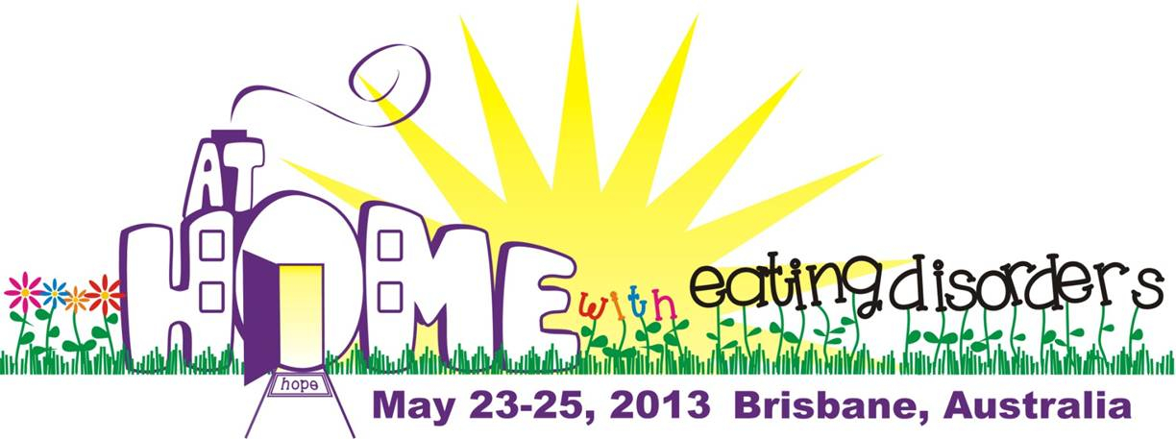
The At Home with Eating Disorders conference committee supports the provision of accessible information about eating disorders and their treatment to sufferers and carers through a variety of means, including public forums and conferences. This conference has been created with the express purpose of providing knowledge, skills and choice to caregivers of people with eating disorders – these caregivers may comprise families, partners, siblings, children, friends, recovery guides. Recovered people and those who are recovering from an eating disorder are, of course, welcome, as are health professionals who want to support and learn from the experience of families/caregivers. However we aim to let all participants know that the focus of this particular conference is firmly on the needs of families /caregivers - so that they can, in turn, better support and care for their loved ones.
It is important that sufferers and carers attending any eating disorders conference give thought as to whether it is the best environment for them at that particular time in their journey, whether the material being presented will meet their needs and if they would benefit from the company of a supporter.

This conference illustrates a big step forward. The organizing committee is a collaboration of four eating disorder organisations – of which one is international, two are national and one is state-based. The organisations represent researchers, health professionals, families and carers, and advocates: F.E.A.S.T., The Butterfly Foundation, the Australian and New Zealand Academy of Eating Disorders (ANZAED) and the Eating Disorder Outreach Service (EDOS, Queensland). Already, I look forward to conferences beyond Brisbane. We want, and need, more of them. We want, and need, more unity, awareness and inclusion of everyone whose life is affected by an eating disorder.

Engagement encourages recovery
I felt nervous and inadequate when attending an eating disorder conference for the first time, in 2009 – it was for professionals, run by the Australian and New Zealand Academy of Eating Disorders. My first book on eating disorders had been released, and I was rich in experience of an eating disorder, but did I have a right to be at this conference? Listening to the keynote speakers discuss research outcomes, I became enthralled and excited – they were describing, and helping me to understand, my life. My illness seemed to be under their microscope. Talk about light bulb moments – they were everywhere. I began to clearly see what thoughts and behaviors belonged to the eating disorder and what was the ‘real me’. Everything began making more sense. I did have a right to be there, and yes, the benefits were many. I departed for home with a new sense of belonging, understanding and hope. I began to believe I was actually an okay person whose life had been sabotaged by an eating disorder bully. Sadly, this revelation came too late for my family of origin to understand, but at least now I was free.

Since then I have attended conferences that include: in the USA (National Eating Disorders Association), UK (Eating Disorders International Conference organized by Beat), Austria (Academy of Eating Disorders) and Australia (ANZAED and National Eating Disorders Collaboration).

By attending conferences, I have learnt more about eating disorders, and about the effect of the illness on my self. I have learnt that while much is known about eating disorders, much remains unknown. I have learnt that some people working in the field of eating disorders can be as challenging as the illness itself. I have learnt that evidence-based treatments often take far too long to become available to sufferers. Above all, I have learnt that ‘evidence from experience’ is largely an untapped resource that, given opportunity, can contribute much to solving the mysteries of eating disorders. Our most eminent and forward-thinking researchers already realize this and describe sufferers as their ‘greatest teachers’.

Network of support
By stepping out, I have acquired a support network comprising researchers, clinicians, advocates, carers, sufferers, and former sufferers of eating disorders. I have progressed from feeling totally inferior to feeling accepted and affirmed as a worthwhile and capable human being. The biggest benefit of ‘coming out’ and engaging in the eating disorder field is the opportunity to apply my experience in turning the mighty force of the illness on to itself.

How can more people with eating disorders get involved? Where can they go to meet others in a safe environment and hear our leading researchers speak? It’s hard to find a conference agenda that caters specifically or primarily for people with eating disorders. Beat’s forerunner, the Eating Disorders Association, ran research conferences with families and sufferers from 1998 onwards. In 2003, the National Eating Disorders Association brought parents and families together with eating disorder professionals and scientific researchers for the first time – its conference title: Building Connections and Mobilizing Families, Educators, Advocates and Professionals. This marked a momentous step forward. Why? The inclusion of people with experience of the illness strengthens the collaborative approach in seeking answers. We need more of it.

Some eating disorder conferences cater for the professionals – people working in research and treatment of eating disorders; other conferences cater for carers and families of people with eating disorders. Where do people with eating disorders go when they want to acquire skills and learn about their illness to aid their own recovery?

Watch for those triggers
Sometimes, people with eating disorders are viewed as a liability: concern is gently expressed that they may find the conference ‘triggering’, or be upsetting to other people attending the conference, and they are discouraged from attending, unless in the company of a full-time carer.

Unfortunately, the eating disorder ‘bully’ capitalizes on any situation. The suggestion that people with eating disorders be accompanied by a carer at a conference can lead to sufferers feeling less than normal, unaccepted, insulted and alienated. Instead of proceeding to ‘come out’ and publicly acknowledge their illness, these sufferers are at risk of regressing and being drawn further into debilitating darkness.

Sufferers deserve to be treated with respect. Yes, they have an illness, but they are people worthy of respect in their own right, first and foremost. They are a rich resource when it comes to learning about eating disorders. While it’s always helpful to have a recovery guide – usually a trusted family member or friend - nearby, including at conferences, attending a conference alone is better than not coming at all. People with eating disorders are super-sensitive and self-conscious, and much encouragement is needed to overcome the eating disorder’s sneaky manipulation of thought to help them get to first base:

- You suspect you may have an illness but are not ready to tell anyone. You just want to come along and learn if your symptoms and behaviors align with those of an eating disorder. Coming along may give you the impetus to seek help for the first time but you are overcome with uncertainty. It’s all in your mind. You can handle this alone. You just need to be more determined. Momentary relief is your reward for deciding to stay home. But soon, you are feeling worse than ever.
- You developed an eating disorder in adolescence, recovered sufficiently to live a part but not full life, and now – in adulthood – you fear a relapse is imminent. You want to come along to the conference to seek knowledge and support. You know you must take a stand, intervene quickly. You may have a partner as your carer, and would like them to accompany you, especially as the conference organisers suggest it is wise, but you can’t quite bring yourself to confide and ask for this support. Your eating disorder bully grabs and translates suggestion for a carer into ‘see, you are weak, you don’t need a carer to go to that silly conference; you don’t need to go at all, you can handle this on your own, all you need is me, me, me’ – and so you don’t go, and your eating disorder gets worse.
- You have an eating disorder – have had one for years, and have been functioning on less than half of your true self. This silent struggle is getting too much to bear. You don’t share your fears with your family because they don’t understand why you are taking so long to ‘get well’ (inference being that your doctor is ‘no good’ and, worse, you are weak-willed). You have been reading helpful books and online pro-recovery blogs. You want to listen to these great keynote speakers at the upcoming conference. You have read the outcomes of their research; you have read the stories of people who have survived the illness. They inspire you and give you hope. To meet them will strengthen your will to overcome this monster within. You want to be pro-active, go to the conference to acquire skills for recovery; but you have two young children and the eating disorder bully triggers guilt thoughts – ‘how can you think of leaving the children, expecting others to care for them? You are selfish, taking several days to go to a conference just for yourself’. Desperate for support, you bravely confide in your sister. She says: All you need to do is think of others instead of yourself. You think about yourself far too much. What makes you think you are so special? Sometimes I think you have Satan in you. You stay home and sink into deeper depression.
- You have done the hard work of recovery and are almost over the line in regaining your true self – you want to attend the conference because you believe it will provide the impetus needed to shut the door on your eating disorder forever. You are upfront in declaring you are ‘a person recovering from an eating disorder’. But the conference organisers’ suggestion that you bring along a recovery guide, someone you know and trust, to get full benefit from the conference, strikes fear that you are less than ‘normal’ (in fact, your bully pounces and says ‘They think you are so incapable that you need a minder; what makes you think you are so good? You will never be normal, stupid’) and you stay home. You regress.

Adults who are aware they have an eating disorder and want to recover, deserve encouragement to attend conferences that shed light on their illness. These people, who are often suffering highly disturbing private torment, while striving to live a partly high functioning life, can benefit greatly from meeting others who are experiencing the same challenges as themselves. I know, because I was one of these people.

Let’s welcome them and help those who are alone to see that, far from being weak, they are brave for taking the big step into this safe and supportive environment. Very soon, they will gain the courage to share their eating disorder secret with a trusted relative or friend who can support them on the recovery journey.

Note the title of a new book co-authored with Professor Janet Treasure: the 1997 1st edition title Anorexia Nervosa, a Survival Guide for Families, Friends and Sufferers, in 2013 has become: Anorexia Nervosa, a Recovery Guide for Sufferers, Families and Friends. Focus has moved from survival to recovery, and there is more emphasis on 'sufferers'; much of the focus is on self-help and self-care guidance – for sufferers, as well as carers. Says a lot.

It’s time to acknowledge sufferers more at conferences. By reaching out, I have found that others feel passionate about this issue.

Sufferers – let’s hear from them

Researchers, support organization leaders, clinicians, carers, former sufferers and sufferers share their views on the rich resource that people who have recovered from an eating disorder can offer, for the benefit of all levels of eating disorder care:

Professor Janet Treasure
Director of Eating Disorder Unit, South London and Maudsley Hospital and Professor at Kings College London
Welcoming people with an eating disorder at a conference designed to improve public awareness is healthy dolphin-like behavior. Any encouragement of being accompanied by a carer needs to be put carefully, to avoid being seen as kangaroo-life behavior.

Professor Cynthia Bulik
Director, UNC Center of Excellence for Eating Disorders University of North Carolina at Chapel Hill
Carer, sufferer, clinician, researcher … our field seems obsessed with locking people into single boxes. The boundaries across these categories are very fuzzy.
Plenty of carers are also sufferers; plenty of clinicians are also sufferers; many researchers are also clinicians; many researchers are also sufferers. There are probably a bunch of sufferer, carer, clinician, researchers too! Most people are "ANDS" not "ORS" when it comes to these categories. Knowing the data on how many clinicians in the field have had eating disorders, I always assume that there are "sufferers" in the audience.
I learn from "sufferers”. "Sufferers" inform my research.… The bottom line is that whatever boxes we inhabit, we all want to eliminate these devastating illnesses.

Claire Vickery
Founder, The Butterfly Foundation
When I started The Butterfly Foundation, ANZAED was the only national eating disorder organisation in Australia and its focus was for researchers and clinicians, not consumers. But I joined anyway!
I was passionate about trying to educate the professionals in the eating disorder field - to help them realise that consumers were individuals who could teach them so much. I reminded the professionals constantly that they didn't have an answer for this illness, that their patients and carers could enlighten them and together we could unravel this disease.

Laura Collins
Founder, F.E.A.S.T.
Advocacy is the right and responsibility of all those involved with eating disorders: patients, their families and friends, clinicians, and others. We all need to ally with one another as a group in common purpose. There are situations where the topic is focused on one type of stakeholder, for example a conference discussing caregiving or research or self-care, but the audience will always be broad and should be inclusive.

Lynn S. Grefe
President and C.E.O., National Eating Disorders Association, New York
Welcoming people affected by eating disorders and their families to our conference in 2003, and thereafter, has been one of the most significant things that NEDA has done. Assuming `those struggling with an eating disorder are well enough to travel, we see that it is a real shot in the arm for them to see how many of us care, want to learn and do more to help…. In this field many continue to say that eating disorders are and have been in the dark, and I say, pull open the curtains, bring in the light of dignity to this illness and the millions of people in it. This light can lead toward advances in treatment and prevention.

Susan Ringwood
Chief Executive Beat, UK, and member of Eating Disorders Advocacy Worldwide campaign
Beat organises an international conference EDIC which has one day specifically programmed to bring together clinicians, researchers, people affected by eating disorders and their families. Professionals who attend consistently report this day as the most effective and successful aspect of the meeting. For people with direct, lived and current experience of eating disorders we give advice about the program, and offer access to support. They can attend any part of the program, which includes research led, medical and technical sections.
People who can share their hard won, lived experience bring a richness and invaluable insight from which we all can learn. Patients, sufferers, survivors, families, loved ones, carers - whatever you call them - have something to teach us all. Let’s hear from them.

Leah Dean
Executive Director, F.E.A.S.T.
Families Empowered and Supporting Treatment of Eating Disorders
No one can escape an eating disorder without support, encouragement and respect. When the situation is that of an actively ill child or young adult under a parent's care, clearly supervision will be needed at any type of triggering event.
Adult patients who live a high functioning life deserve the same support, encouragement and respect but not necessarily supervision. I sometimes worry that we inadvertently perpetuate the benefits of hiding one's illness and not seeking needed care.
We trust high functioning adults every day of our lives to run businesses, teach our children, and so on, without knowing their medical histories. We praise people every day for exceptional work and dedication to health and fitness, until we discover they have an eating disorder. This gives patients all the more reason to hide their illnesses and works against our very mission.
The descriptions in this article of various mental scenarios, where the Ed Bully derails a patient’s desire to seek help, or to educate themselves about the very disease that torments them, are perfect examples of the valuable insight that patients can provide to caregivers and treatment providers. This article is a reminder of why we all need to work together to improve access to information, treatment, and towards eliminating stigma.

Anthea Fursland
President of ANZAED
It all depends where the individual is in terms of her/his recovery. I am concerned, because I do know of occasions where sufferers have felt overwhelmed at conferences, and I wouldn’t want conference attendees to experience any undue distress. I do agree that there needs to be a forum for sufferers and clinicians to connect.

Becky Henry
Founder of Hope Network, USA
Inclusion of sufferers can be delicate depending on where in the recovery process someone is. Inclusion can provide not only a lifeline for the sufferer but also valuable insights to families and clinicians. My hope is that, those who have an eating disorder, and are aware they want to recover, also will have opportunity to learn skills and acquire knowledge to guide them on their way to freedom. We all have a place at the table.

Jenni Schaefer
NEDA Ambassador Council chair, author of Goodbye Ed, Hello Me
Years ago, my eating disorder thrived on making me feel "less than" and encouraging isolation. To get better, I needed everyone around me to combat those two messages. And, finally, with this kind of support, I was able to fight for myself.
Many of the clinicians who helped me to recover told me that it was their clients struggling with eating disorders who actually taught them how to treat the illness. It wasn't school or a book but rather the experience of working one-on-one with individuals. Each and every person who battles an eating disorder has a powerful story to tell and an experience that can teach all of us. I have been welcomed into the eating disorder field as a teacher, and for that, I am deeply grateful. My hope is that, as a field, we continue welcoming people who have suffered.

Carrie Arnold
Blogger at EDBites.com, author of Decoding Anorexia
Sufferers have a lot to say, and a lot to give. I started my blog, ED Bites, before I was fully well. Although I don't recommend that people launch themselves headlong into eating disorder-related endeavors before achieving full wellness (your own recovery comes first), I found I could help others by sharing my own personal journey to recovery.

Most sufferers and former sufferers do want to give back somehow. My own ways of contributing aren't always traditional (blogging about research and eating disorders), but they fit me. I find them tremendously rewarding and they help strengthen my own recovery. I told myself when I started blogging that I would never deliberately lie to my readers. Although I haven't shared everything in my life for privacy reasons, I admitted when I had a terrible relapse, and the support I got was absolutely amazing. Building a supportive community for myself that included people I knew in real life (my parents, my boyfriend) and online has been a huge help.

The best part for me is when people tell me how much they enjoy my blog. It shows me that my work and my life are really important.

Veronica Kamerling
By coming to an eating disorder conference on their own, sufferers are showing that they are taking responsibility for their own lives. If they have the bonus of having their carer with them then that is very much a plus, as collaborative care in terms of positive results is very important. Encouraging people with eating disorders to come in their own right is helpful and in the spirit of recovery.

Fiona Bromelow
People, including those with an interest in eating disorders, come in all shapes and sizes. Besides the sufferers we know about, there are parents who have had/do have eating disorders themselves, there are fully recovered people who have masses to give, there are partially recovered people who have masses to give. They all have something to give.

Cate Sangster
There is still work to do in overcoming the stigma that people with a mental illness may disturb others in attendance at eating disorder conferences. This sense that someone with an eating disorder needs to be kept away from the ‘nice normal people’ has caused much shame and discouraged many from seeking help. This stigma has been especially disappointing when perpetuated in a forum where it should be fought.

Hays Brown
As a sufferer, I was granted permission to attend a NEDA eating disorder conference. I was 28 years old and living a "half-life" at best ... on a good day. I did not have a carer at home, let alone one whom I would have asked, or wanted, to attend a conference with me. I desired to attend a conference because:
- I wanted to meet face-to-face the motivational authors of the books that I had read for years and years…. I wanted to see these people with my own eyes. And, I wanted to hear their words - words I knew were meant for me. In hindsight, I believe I was seeking a connection to the RECOVERED world of which I dreamed to belong.
- In addition to meeting RECOVERED individuals, I also believed whole-heartedly that a conference would inspire and help me help myself. Possibly. I was seeking desperately any source of inspiration that would counter the defeat that I felt as a result of my own struggle.
- Not only was this conference a healing experience for me, but it was also the beginning of invaluable friendships that I hold dear to this day.

Gill Ryan
Carers and families should have a conference where they can feel safe to say what they feel. In the presence of sufferers their comments must necessarily be qualified. They need an arena in which they can speak the “unspeakable” and share these words and feeling with others in a similar position. Only then will they be able to feel the empathy and companionship of fellow carers and fellow family members of sufferers. Only then will they feel safe enough to absorb helpful words or advice. … This view does not in any way discount the pain of a sufferer nor does it devalue them in any way; it just brings the carers and family members to the “centre stage”.
Pooky Knightsmith
Blogger at www.eatingdisordersadvice.co.uk
Damage is done when an eating disorder conference feels like a club that you can only join if you are mentally healthy. … Safeguards are needed – but surely a gathering of several hundred carers, experts and people with eating disorders can be made into a safe haven for those still fighting the battle?
Shannon Cutts
Executive Director, MentorCONNECT

It’s time for the eating disorders conference world to invite and welcome all sufferers who want to attend and learn. Welcoming sufferers to these events will spread the wealth of knowledge about what works best in treating eating disorders much further, much faster.

As well, welcoming the sufferers will showcase firsthand to the recovering community that many professionals DO truly care and understand what suffering people are going through. Right now, there is an equally wide gap between professionals who want their patients to trust them and patients who feel willing to trust. On MentorCONNECT, many of our members share that initially they don’t want to open up to their treatment teams for fear they will be misunderstood, shamed or dismissed. But after encouragement from mentors and peers who are farther along on the recovery path, many do eventually recommit to professional treatment at a much deeper level and go on to achieve lasting recovery.

Conference organizers must be willing to practice what they prescribe and invite sufferers into their midst so that we can face our fears, learn and heal together.

Conclusion
Conferences about eating disorders are important for the dissemination of research findings, sharing of knowledge and ideas. They are important for fostering of collaboration and consensus in the field of eating disorders. The focus of conferences can vary – for researchers, clinicians, treatment providers, carers, advocates. Sometimes the various sectors need a strict focus for freedom of discussion – for instance, F.E.A.S.T. provides families and carers with a place – both online and at symposiums - where they can safely and openly talk about issues that might be necessary to discuss from a carer perspective that could be triggering to those they are caring for. MentorCONNECT provides an online forum for sufferers for the same reason - the needs of sufferers and carers tend to differ significantly enough that they each require their own space to interact and connect. Researchers and clinicians also need their space where they can debate and share.
Then there are conferences which are all inclusive – for professionals, carers, families, clinicians and, yes, people with eating disorders.
Each event contributes to the eating disorder field but we can always do more. People with eating disorders, together with people who have recovered from their eating disorder, remain a largely untapped resource in learning about and solving the mystery of their illness.
This discussion paper brings to light the need for a sufferers-focused event or conference - organized specifically to speak to the information and support needs of people with eating disorders.
If a researcher, clinician or carer attends a conference and something they hear helps them save a life, then the entire conference has been a success.
If a sufferer attends a conference and something they hear helps them save their own life, the entire conference has been an even greater success.

Books by the author

A Clinician’s Guide to Binge Eating Disorder. Co-editors Andrea Goldschmidt, Daniel Le Grange. Routledge 2013.

Anorexia Nervosa: A Recovery Guide for Sufferers, Families and Friends.Co-author Janet Treasure. 2nd edition: Routledge 2013.

Ed Says U Said – Eating Disorder Translator. Co-author Cate Sangster. Jessica Kingsley Publishers, UK, 2013. Australia and NZ click here.

A Collaborative Approach to Eating Disorders. Co-editor Prof. Janet Treasure of Routledge. 2012.

Memoir A Girl Called Tim, Escape from an Eating Disorder Hell, New Holland Publishers 2010.

My Kid is Back - Empowering Parents to Beat Anorexia Nervosa. Routledge. 2010.

Current work: Co-author of Multi-Family Therapy – Our Kids are Back, with Prof. Ivan Eisler, King’s College, London. Routledge (UK) 2014.

Further information: www.junealexander.com

Acknowledgement: to Cate Sangster for creating the two illustrations in this article.

